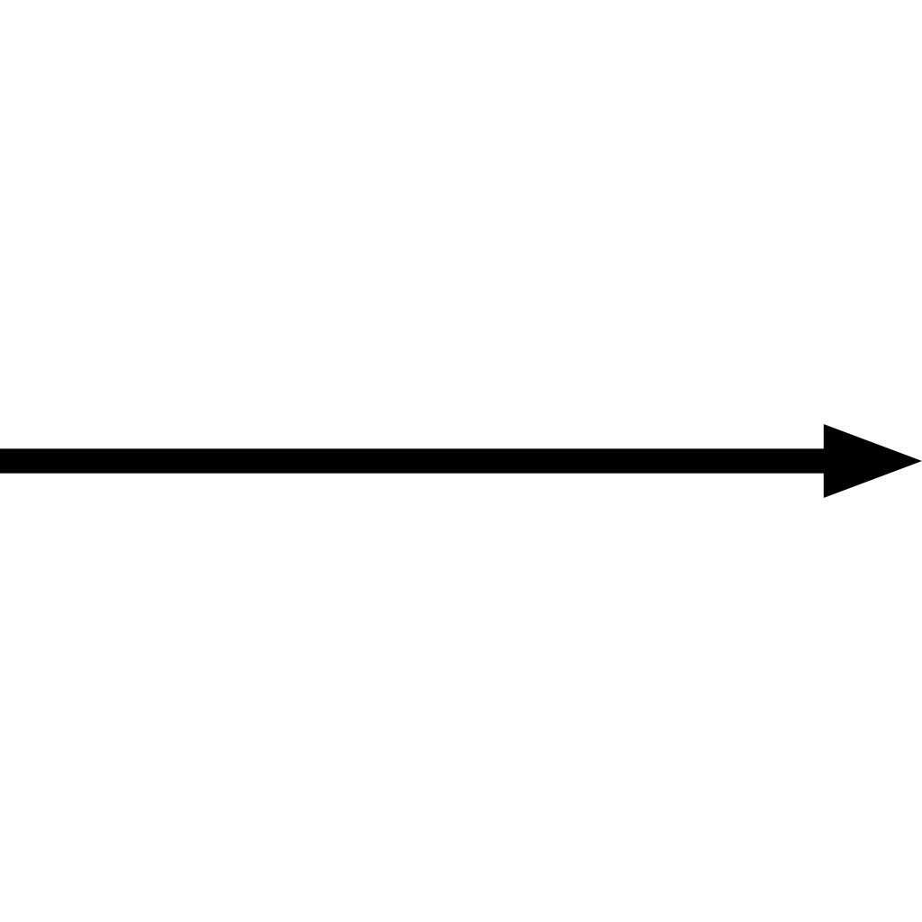

*If you are just beginning your Flask journey, you’ll start by installing pipenv globally once...*

*Then you’ll be set to create each of your flask projects as follows:*

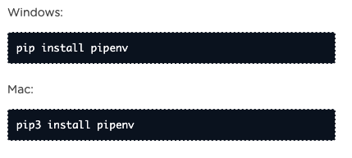

1. mkdir <project folder>  *// Create project folder //*
2. cd <project folder>  *// Navigate into project folder //*
3. pipenv install flask ***-or-*** python3 -m pipenv install flask

*// the virtual environment “pipenv” will install Flask into the project folder //*

1. $ pipenv shell *//activates virtual environment//*



// *the virtual environment will need to be active in order to run your project, to when you are done, or to exit the shell, just type exit in the command line //*

1. Open the project folder in your code editor
2. Create a server.py, templates folder, static folder within the project folder
3. Boilerplate server.py code:

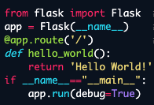

// remember to import render_template, request, redirect + whatever else you may need to run your code /

1. python server.py //this command will run your server at http://localhost:5000 ensure your environment is active (command is pipenv shell) or this won’t work!
2. **Congrats! Take a breather- you’ve got your project set up!**